WINE SAMPLE ANALYSIS
NAME- AVADHUT CHODANKAR
import numpy as np
import pandas as pd
import matplotlib.pyplot as plt
import seaborn as sns
from sklearn.model_selection import train_test_split
from sklearn.ensemble import RandomForestClassifier
from sklearn.metrics import accuracy_score
DATA COLLECTION
# loading the dataset to a Pandas DataFrame
wine_dataset = pd.read_excel("/content/drive/MyDrive/wine analysis/winequality-red.xlsx")
# number of rows & columns in the dataset
wine_dataset.shape
(1599, 12)
# first 5 rows of the dataset
wine_dataset.head()
fixed acidity volatile acidity citric acid residual sugar chlorides \
0 7.4 0.70 0.00 1.9 0.076
1 7.8 0.88 0.00 2.6 0.098
2 7.8 0.76 0.04 2.3 0.092
3 11.2 0.28 0.56 1.9 0.075
4 7.4 0.70 0.00 1.9 0.076
free sulfur dioxide total sulfur dioxide density pH sulphates \
0 11.0 34.0 0.9978 3.51 0.56
1 25.0 67.0 0.9968 3.20 0.68
2 15.0 54.0 0.9970 3.26 0.65
3 17.0 60.0 0.9980 3.16 0.58
4 11.0 34.0 0.9978 3.51 0.56
alcohol quality
0 9.4 5
1 9.8 5
2 9.8 5
3 9.8 6
4 9.4 5
# checking for missing values
wine_dataset.isnull().sum()
fixed acidity 0
volatile acidity 0
citric acid 0
residual sugar 0
chlorides 0
free sulfur dioxide 0
total sulfur dioxide 0
density 0
pH 0
sulphates 0
alcohol 0
quality 0
dtype: int64
DATA ANALYSIS AND VISUALISATION
# statistical measures of the dataset
wine_dataset.describe()
fixed acidity volatile acidity citric acid residual sugar \
count 1599.000000 1599.000000 1599.000000 1599.000000
mean 8.319637 0.527821 0.270976 2.538806
std 1.741096 0.179060 0.194801 1.409928
min 4.600000 0.120000 0.000000 0.900000
25% 7.100000 0.390000 0.090000 1.900000
50% 7.900000 0.520000 0.260000 2.200000
75% 9.200000 0.640000 0.420000 2.600000
max 15.900000 1.580000 1.000000 15.500000
chlorides free sulfur dioxide total sulfur dioxide density \
count 1599.000000 1599.000000 1599.000000 1599.000000
mean 0.087467 15.874922 46.467792 0.996747
std 0.047065 10.460157 32.895324 0.001887
min 0.012000 1.000000 6.000000 0.990070
25% 0.070000 7.000000 22.000000 0.995600
50% 0.079000 14.000000 38.000000 0.996750
75% 0.090000 21.000000 62.000000 0.997835
max 0.611000 72.000000 289.000000 1.003690
pH sulphates alcohol quality
count 1599.000000 1599.000000 1599.000000 1599.000000
mean 3.311113 0.658149 10.422983 5.636023
std 0.154386 0.169507 1.065668 0.807569
min 2.740000 0.330000 8.400000 3.000000
25% 3.210000 0.550000 9.500000 5.000000
50% 3.310000 0.620000 10.200000 6.000000
75% 3.400000 0.730000 11.100000 6.000000
max 4.010000 2.000000 14.900000 8.000000
# number of values for each quality
sns.catplot(x='quality', data = wine_dataset, kind = 'count')
<seaborn.axisgrid.FacetGrid at 0x7f6c2d18ea90>
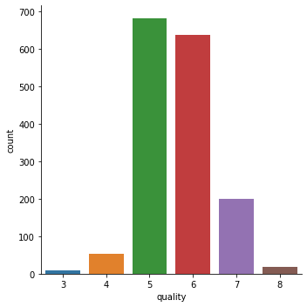
# volatile acidity vs Quality
plot = plt.figure(figsize=(5,5))
sns.barplot(x='quality', y = 'volatile acidity', data = wine_dataset)
<matplotlib.axes._subplots.AxesSubplot at 0x7f6c2b263a10>
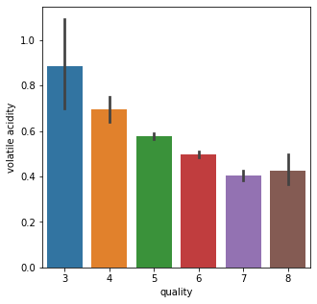
# citric acid vs Quality
plot = plt.figure(figsize=(5,5))
sns.barplot(x='quality', y = 'citric acid', data = wine_dataset)
<matplotlib.axes._subplots.AxesSubplot at 0x7f6c28540350>
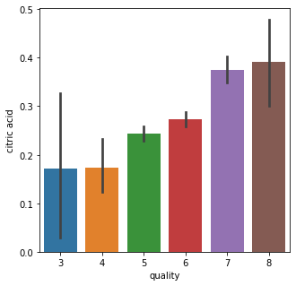
CORRELATION
- POSITIVE CORRELATION
- NEGATIVE CORRELATION
correlation = wine_dataset.corr()
# constructing a heatmap to understand the correlation between the columns
plt.figure(figsize=(10,10))
sns.heatmap(correlation, cbar=True, square=True, fmt = '.1f', annot = True, annot_kws={'size':8}, cmap = 'Blues')
<matplotlib.axes._subplots.AxesSubplot at 0x7f6c2b3c1190>
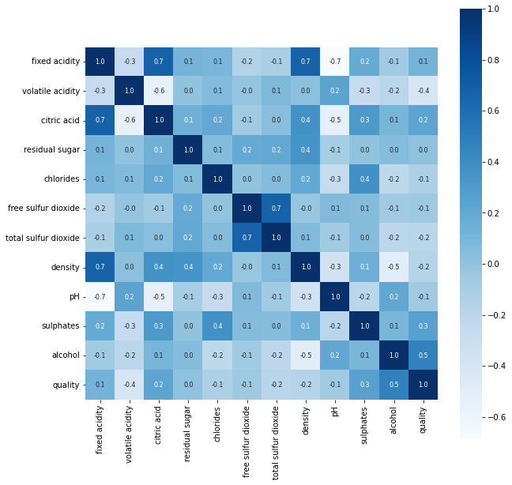
DATA PREPROCESSING
# separate the data and Label
X = wine_dataset.drop('quality',axis=1)
print(X)
fixed acidity volatile acidity citric acid residual sugar chlorides \
0 7.4 0.700 0.00 1.9 0.076
1 7.8 0.880 0.00 2.6 0.098
2 7.8 0.760 0.04 2.3 0.092
3 11.2 0.280 0.56 1.9 0.075
4 7.4 0.700 0.00 1.9 0.076
... ... ... ... ... ...
1594 6.2 0.600 0.08 2.0 0.090
1595 5.9 0.550 0.10 2.2 0.062
1596 6.3 0.510 0.13 2.3 0.076
1597 5.9 0.645 0.12 2.0 0.075
1598 6.0 0.310 0.47 3.6 0.067
free sulfur dioxide total sulfur dioxide density pH sulphates \
0 11.0 34.0 0.99780 3.51 0.56
1 25.0 67.0 0.99680 3.20 0.68
2 15.0 54.0 0.99700 3.26 0.65
3 17.0 60.0 0.99800 3.16 0.58
4 11.0 34.0 0.99780 3.51 0.56
... ... ... ... ... ...
1594 32.0 44.0 0.99490 3.45 0.58
1595 39.0 51.0 0.99512 3.52 0.76
1596 29.0 40.0 0.99574 3.42 0.75
1597 32.0 44.0 0.99547 3.57 0.71
1598 18.0 42.0 0.99549 3.39 0.66
alcohol
0 9.4
1 9.8
2 9.8
3 9.8
4 9.4
... ...
1594 10.5
1595 11.2
1596 11.0
1597 10.2
1598 11.0
[1599 rows x 11 columns]
LABEL BINARIZATION
Y = wine_dataset['quality'].apply(lambda y_value: 1 if y_value>=7 else 0)
print(Y)
0 0
1 0
2 0
3 0
4 0
..
1594 0
1595 0
1596 0
1597 0
1598 0
Name: quality, Length: 1599, dtype: int64
TRAIN AND TEST SPLIT
X_train, X_test, Y_train, Y_test = train_test_split(X, Y, test_size=0.2, random_state=3)
print(Y.shape, Y_train.shape, Y_test.shape)
(1599,) (1279,) (320,)
MODEL TRAINING:
RANDOM FOREST CLASSIFIER
model = RandomForestClassifier()
model.fit(X_train, Y_train)
RandomForestClassifier()
MODEL EVALUATION
ACCURACY SCORE
# accuracy on test data
X_test_prediction = model.predict(X_test)
test_data_accuracy = accuracy_score(X_test_prediction, Y_test)
print('Accuracy : ', test_data_accuracy)
Accuracy : 0.928125
BUILDING A PREDICTIVE SYSTEM
input_data = (7.5,0.5,0.36,6.1,0.071,17.0,102.0,0.9978,3.35,0.8,10.5)
# changing the input data to a numpy array
input_data_as_numpy_array = np.asarray(input_data)
# reshape the data as we are predicting the label for only one instance
input_data_reshaped = input_data_as_numpy_array.reshape(1,-1)
prediction = model.predict(input_data_reshaped)
print(prediction)
if (prediction[0]==1):
print('Good Quality Wine')
else:
print('Bad Quality Wine')
[0]
Bad Quality Wine
/usr/local/lib/python3.7/dist-packages/sklearn/base.py:451: UserWarning: X does not have valid feature names, but RandomForestClassifier was fitted with feature names
"X does not have valid feature names, but"

